1. Create a Visualforce page as shown below and it should save the case record.

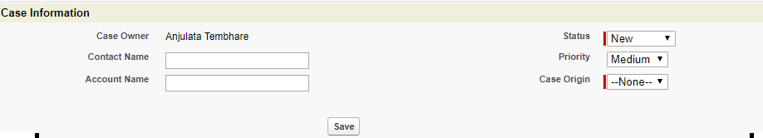

Add this to the edit Button on case page.

1. Create Tabbed Visualforce page which will have Account details on First Tab and Second Tab should have list of Contacts for that Account and third tab for Opportunities.
2. Create a Training App with two objects – Employee and Department

Department object:

|  |  |  |
| --- | --- | --- |
| Field Label | API Name | Data type |
| Change Name to DepartmentID | - | AutoNumber |
| Department Name | APEX_Department_Name__c | Text(25) |
| Location | APEX_Location__c | Text(25) |

Employee object:

|  |  |  |
| --- | --- | --- |
| Field Label | API Name | Data type |
| Change Name to Emp No | - | AutoNumber |
| First Name | APEX_First_Name__c | Text(25) |
| Last Name | APEX_Last_Name__c | Text(25) |
| Department | APEX_Department__c | Master-Detail |
| Salary | APEX_Salary__c | Number(20) |
| Grade | Apex_Grade__c | Pick list – (A1-A5, B!,B2, C1,C2) |

Use Apex to do the following:

1. Add 5 Departmentss to Department Object where 2 Department names should have ‘LnD’ in it, with at least 2 employees for each department
2. Display list of all departments
3. Display List of all Employees who who are in B grade along and list of students who are in C grade.
4. Create SOSL to find All ‘LnD’ Departments